Introduction 1

Background 1

Introducing CLAS Standards 1

How to navigate this toolkit 3

How to use the Self-assessment Checklist and Action Plan Table template 4

A quick note on the Principal Standard 4

Theme 1: Governance, Leadership, and Workforce 5

Standard 2: Advance and sustain organizational governance and leadership that promote CLAS and health equity through policy, practices, and allocated resources. 5

CLAS Standards 2 Policy example: Governance and Leadership that Promotes CLAS and Health Equity Policy 7

Resources specific to Standard 2 7

Theme 1: Governance, Leadership, and Workforce 9

Standard 3: Recruit, promote, and support a culturally and linguistically diverse governance, leadership, and workforce that are responsive to the population in the service area. 10

CLAS Standards 3 Policy example: Recruitment, Promotion, and Supporting a Diverse Governance, Leadership, and Workforce 12

Resources specific to Standard 3 12

Theme 1: Governance, Leadership, and Workforce 13

Standard 4: Educate and train governance, leadership, and workforce in culturally and linguistically appropriate policies and practices on an ongoing basis 14

CLAS Standard 4 Policy example: Education and Training for Governance, Leadership, and Workforce in CLAS 15

Resources specific to Standard 4 15

Glossary 17

Appendices 18

Appendix 1: Step-by-Step guide to NCLAS 19

Appendix 2: Resources for implementation 19

Standard 2 & 3-specific: Checklist to Facilitate the Development of Culturally and Linguistically Competent Primary Health Care Policies and Structures 20

Reflecting and Respecting Diversity Checklist (Standard 3) 20

Appendix 3: Diversity in Governance and Leadership 21

Step-by-step guide to Governance and Leadership assessment 22

Diversity in Governance and Leadership checklist (Standard 3) 22

Appendix 4: Example action plan 23

Introduction

Background

The Arizona Targeted Investments Program 2.0 (AZ TIP 2.0) is a state-wide initiative that aims to improve the quality and outcomes of health care services for Medicaid members.

The program's main purpose is to encourage and support providers in developing improved systems and strategies for delivering integrated whole person care. An approach to care that addresses a patient’s immediate, mental, and social health needs comprehensively.

The program also seeks to tackle health disparities within their patient population. Key to addressing and tackling health disparities **especially among minority communities** is the provision of care that is **culturally responsive**. To support this need, AZ TIP 2.0 includes an initiative for implementing the National Standards for Culturally and Linguistically Appropriate Services in Health and Health Care (NCLAS) Standards. The first CLAS Standards were published by OMH in 2000 and in 2010-2013 they underwent an Enhancement initiative to incorporate the past decade’s advancements, expand their scope and improve their clarity to ensure understanding and implementation. The Enhanced NCLAS standards can be referenced below.

## Introducing CLAS Standards

The state of Arizona’s population is diverse:

* **32.5%** of the population identifies as Hispanic or Latino,
* **5.2%** as American Indian or Alaska Native,
* **5.5%** as Black or African American, and
* **3.9%** as Asian.[1](https://www.census.gov/quickfacts/fact/table/AZ/PST045222)

Among Arizona’s Medicaid population:

* **37.89%** are Hispanic or Latino,
* **8.23%** are American Indian or Alaska Native,
* **8.22%** are Black or African American, and
* **1.51%** are Asian.[2](https://www.azahcccs.gov/Resources/Downloads/PopulationStatistics/2024/Demographics_01012024.pdf)

Arizona’s population is also linguistically diverse, with many speaking English less than very well:

* Spanish speakers: 32.5%
* Arabic speakers: 31.8%
* French (including Cajun) speakers: 16.7%
* German speakers: 13.1%
* Hindi speakers: 10.9%
* Tamil speakers: 18.1%
* Chinese (including Mandarin, Cantonese) speakers: 42.9%
* Korean speakers: 50.5%
* Vietnamese speakers: 50.9%
* Tagalog (including Filipino) speakers: 22.2%
* Speakers of other Native languages of North America: 14.4%[3](https://data.census.gov/table/ACSDT1Y2022.B16001?q=language%20spoken%20at%20home%20&g=040XX00US04.)

Given this demographic and linguistic composition, it is essential to provide care that is responsive to the cultural and linguistic needs of these populations. This approach is fundamental to addressing health disparities and enhancing health outcomes.

The NCLAS or CLAS Standards are a set of 15 guidelines, grouped by themes, that provide a framework for health care organizations to deliver services that are culturally and linguistically appropriate.

They are intended to advance health equity, improve quality, and help eliminate health care disparities. By implementing the CLAS Standards, health care providers can better serve and improve health outcomes for the diverse communities in Arizona through providing care that is responsive to different cultural backgrounds, beliefs, values, and preferences.

In alignment with integrated whole person care, CLAS Standards implementation addresses the **social** and **structural factors** that contribute to health disparities and can **enhance communication**, **patient education**, **informed consent**, **data collection**, and **quality improvement**, among other aspects of care. In addition, these practices can help reduce barriers to access, increase patient satisfaction and engagement, promote patient safety and empowerment, and improve health literacy and self-management skills.

To sum up, the adoption of CLAS Standards in Arizona’s healthcare system is a pivotal step towards enhancing health outcomes by delivering culturally and linguistically appropriate services. This approach caters to the diverse needs of the state’s population and plays a significant role in mitigating health disparities, thereby fostering health equity. As we transition into the next section of this toolkit, you will be equipped with practical tools and strategies to effectively implement these CLAS Standards in your healthcare practice. The forthcoming section will empower you to transform these theoretical guidelines into actionable steps.

THE ENHANCED NATIONAL CLAS STANDARDS

The Enhanced National Culturally and Linguistically Appropriate Standards are organized as one Principal Standard and three themes:

**Principal Standard:**

1. Provide effective, equitable, understandable, and respectful quality care and services that are responsive to diverse cultural health beliefs and practices, preferred languages, health literacy, and other communication needs.

**Governance, Leadership and Workforce: TI Year 2 milestone**

1. Advance and sustain organizational governance and leadership that promotes CLAS and health equity through policy, practices and allocated resources.
2. Recruit, promote, and support a culturally and linguistically diverse governance, leadership, and workforce that are responsive to the population in the service area.
3. Educate and train governance, leadership, and workforce in culturally and linguistically appropriate policies and practices on an ongoing basis.

**Communication and Language Assistance: TI year 3 milestone**

1. Offer language assistance to individuals who have limited English proficiency and/or other communication needs, at no cost to them, to facilitate timely access to all health care and services.
2. Inform all individuals of the availability of language assistance services clearly and in their preferred language, verbally and in writing.
3. Ensure the competence of individuals providing language assistance, recognizing that the use of untrained individuals and/or minors as interpreters should be avoided.
4. Provide easy-to-understand print and multimedia materials and signage in the languages commonly used by the populations in the service area.

**Engagement, Continuous Improvement, and Accountability: TI Year 3 milestone**

1. Establish culturally and linguistically appropriate goals, policies, and management accountability, and infuse them throughout the organization’s planning and operations.
2. Conduct ongoing assessments of the organization’s CLAS-related activities and integrate CLAS-related measures into measurement and continuous quality improvement activities.
3. Collect and maintain accurate and reliable demographic data to monitor and evaluate the impact of CLAS on health equity and outcomes and to inform service delivery.
4. Conduct regular assessments of community health assets and needs and use the results to plan and implement services that respond to the cultural and linguistic diversity of populations in the service area.
5. Partner with the community to design, implement, and evaluate policies, practices, and services to ensure cultural and linguistic appropriateness.
6. Create conflict and grievance resolution processes that are culturally and linguistically appropriate to identify, prevent and resolve conflicts or complaints.
7. Communicate the organization’s progress in implementing and sustaining CLAS to all stakeholders, constituents, and the general public.

How to navigate this toolkit

This toolkit provides an overview of the CLAS Standards and offers practical guidance and resources for primary health care providers to help meet TI 2.0 milestones for year 2. The toolkit covers topics such as:

1. Conducting a self-assessment,
2. Developing an action plan,
3. Example strategies, and
4. Resources to assist you in implementation.

The self-assessment is a checklist and is combined with an action plan table template in table format to keep forms together on one document. Templates for standards 2-4 (for year 2 milestone) **are provided as separate documents** **for ease of printing and completing in writing**.

The strategies included are **examples** that your practice could implement**. You will need to tailor your strategy to reflect your individual practice setting** to meet the requirements for each standard. Additionally, at the end of each standard are resources specific to each standard and policy templates to assist your practice in developing policies that address components needed to achieve CLAS Standards 2-4. The specific items in each policy can be tailored as needed. Also at the end of the toolkit is a glossary section with common terms you’ll hear related to CLAS Standards and culturally appropriate and competent care.

How to use the Self-assessment Checklist and Action Plan Table template

**Step 1:** Start by identifying your organization’s current stage of implementation for each practice (highlighted in bold) under the standard. Check the box that corresponds to your organization’s status in the blank template.

**Step 2:** After completing the self-assessment checklist, indicate in the section below which two tactics from the checklist your organization is **currently** implementing. Provide relevant details. If your organization is not implementing any tactics, leave this section blank and proceed to **Step 3. Note** that if your organization is not implementing any tactic by the time the milestones are due, you may be at risk of not earning the incentive aligned with the milestone.

**Step 3:** Choose a maximum of **two** tactics from the list for Standards 2 and 3 to implement and meet the requirements. For Standard 4, select **three** tactics. Refer to the “List of Tactics” under each Standard’s self-assessment and action planning template to explore potential strategies for your organization.

**Step 4:** For each tactic you’ve chosen, list 3-5 major actions in the “Action” column. Identify who will be involved or needs to be involved in completing each action in the “Owner” column. In the “When” column, specify the deadline for each action.

**Step 5:** Before starting your implementation efforts, it’s important to appoint a **CLAS champion** or **champions** who will spearhead the implementation initiatives for your practice.

A quick note on the Principal Standard

For assessment and action planning purposes, the Principal Standard **will not be included** as standards 2-15 are the components to achieve the Principal Standard; this is the ultimate aim of implementation. If your organization implements and maintains Standards 2-15, or 2-13 for the Targeted Investments Program CLAS Standards initiative, you will be positioned to achieve the Principal Standard.

**The tables below are templates with instructions on how to fill. The actual template you will use in practice for each standard will be provided as a separate document you can edit in Microsoft Excel or print out and fill in manually.**

Theme 1: Governance, Leadership, and Workforce

## Standard 2: Advance and sustain organizational governance and leadership that promote CLAS and health equity through policy, practices, and allocated resources.

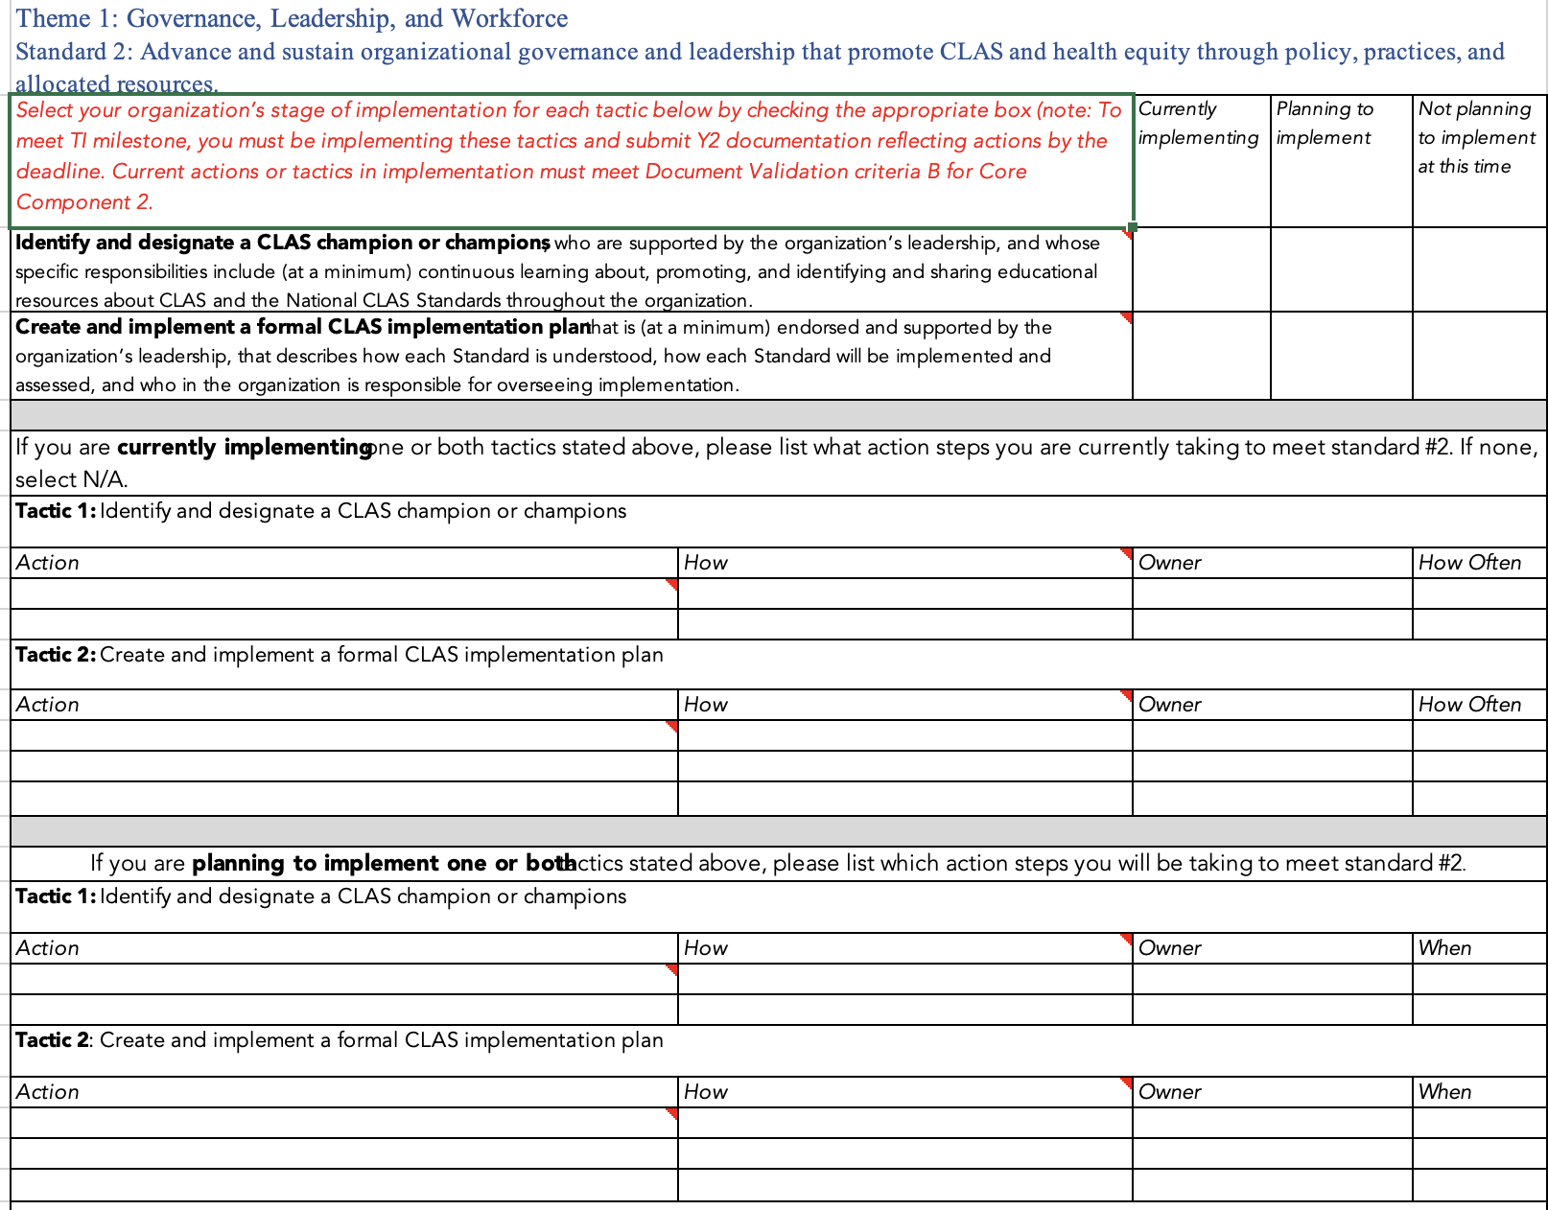

Actions for Tactic 1

1. **Identify and designate an individual CLAS champion with specific responsibilities that include promoting the incorporation of the CLAS Standards. Includes individuals representing diverse communities (e.g., racial/ethnic minority, LGBTQIA+, and individuals with disabilities).**
2. **Form a CLAS team (for larger practices) that includes multidisciplinary and diverse individuals, including administrators, providers, and frontline staff. CLAS champions will have specific responsibilities that include promoting the incorporation of the CLAS Standards.**   
   **Includes individuals representing diverse communities (e.g., racial/ethnic minority, LGBTQIA+, and individuals with disabilities).**

Actions for Tactic 2

1. **Create a strategic plan that incorporates policies, procedures, staff and financial resources, and organizational systems to support CLAS efforts.**
2. **Embed a commitment to culturally competent care in the vision, goals, mission, and strategic plan of the organization.**
3. **Regularly review and update organizational policies and practices to reflect the CLAS Standards.**

**A NOTE ON FILLING IN THE POLICY TEMPLATE BELOW!**

The actions you selected from the “List of actions” above, should be the same you indicate in the action plan **and** policy template. In practice, you must select action steps from a drop-down in the template OR write in the action steps if printing or implementing an action not indicated in the drop down. If helpful, you may attach the completed action plan as an appendix to your completed policy.

CLAS Standards 2 Policy example: Governance and Leadership that Promotes CLAS and Health Equity Policy

TIN # [*insert TIN*]

Practice Name [*insert practice name*]

The following policy outlines how [*insert* *practice name*] will uphold Standard 2 of the National Standards for Culturally and Linguistically Appropriate Services (NCLAS) in Health and Health Care:

Advance and sustain organizational governance and leadership that promotes CLAS and health equity through policy, practices, and allocated resources.

Our practice is committed to providing high-quality, patient-centered, and culturally responsive care to all our patients, regardless of their race, ethnicity, language, religion, gender identity, sexual orientation, disability, or socioeconomic status. To achieve this goal, we will:

* *Create and sustain an environment of cultural competency through establishing leadership structures and systems or embedding them into existing structures and systems. (example)*
* *[Insert tactic from table to meet standard here]*
* *[Insert tactic from table to meet standard here]*
* *[Insert tactic from table to meet standard here]*
* *[Insert tactic from table to meet standard here]*

We will monitor and evaluate our performance on CLAS and health equity annually and adjust as needed to ensure continuous improvement.

Appendix/Appendices

*[Attach completed action plan from Excel sheet by copying the complete table and pasting as an image to your completed policy]*

Resources specific to Standard 2

|  |  |  |  |
| --- | --- | --- | --- |
|  | **Resource** | **Description** | **Link** |
| **For additional reading** | Checklist to Facilitate the Development of Culturally and Linguistically Competent Primary Health Care Policies and Structures | The goal of this checklist is to facilitate policy making that supports culturally and linguistically competent primary health care services.  Also available in **Appendix 2** | <https://nccc.georgetown.edu/documents/Policy%20Brief%201%20Checklist.pdf> |
| Cultural Competence in Governance | This page provides some tips on how to improve the cultural competence of an organization, based on eight domains of assessment and action. Also included on this site are PDF tips sheets for each domain. | <https://www.ceh.org.au/resource-hub/cultural-competence-in-governance/> |
| Literature Review of the National CLAS Standards: Policy and Practical Implications in reducing health disparities | This article reviews the National CLAS Standards highlighting their role as a practical tool for organizations to enhance service provision to diverse cultural and linguistic populations. Additionally, it highlights the challenges faced by health care organizations in implementing these standards, such as communication issues within organizations and inconsistent accountability measures, contributing to the knowledge base on CLAS and health disparities. | https://www.researchgate.net/publication/305523338_Literature_Review_of_the_National_CLAS_Standards_Policy_and_Practical_Implications_in_Reducing_Health_Disparities?enrichId=rgreq-a4eea5141e54a7c3fb5c31711a3f1177-XXX&enrichSource=Y292ZXJQYWdlOzMwNTUyMzMzODtBUzo5MTIxNzUyNjY4MTE5MDVAMTU5NDQ5MDkzOTczNA%3D%3D&el=1_x_3&_esc=publicationCoverPdf |
| A Scoping Review of the Literature: Content, Focus, Conceptualization and Application of the National Standards for Culturally and Linguistically Appropriate Services in Health Care | The aim of this scoping review was to identify the scientific and professional literature related to the CLAS standards and describe the content, focus, conceptualization and application of these publications, with the goal of providing insights and directions for further research and application of the CLAS standards | https://muse.jhu.edu/article/597749 |
| National Culturally and Linguistically Appropriate Services Standards—Mandates or Not? | This article seeks to clarify the contradiction on whether LEP requirements are mandates or not so that public health advocates and experts can provide accurate information to people they serve and consider whether they should work with to develop truly mandatory language access standards as a condition of federal funding. | https://muse.jhu.edu/article/481722 |
| **For a deep dive** | The Cultural & Linguistic  Competence (CLC) Hub of the  Technical Assistance Network for Children’s Behavioral Health (TA Network), Resource Brief 2: Implementing the CLAS Standards | While aimed at Behavioral Health organizations, is also applicable to other healthcare settings. This guide is meant to aid in developing and implementing policies, providing services and supports, and conducting on-going quality improvement activities for organizations in their system of care to meet the CLAS Standards. | <http://cfs.cbcs.usf.edu/projects-research/_docs/CLC_ResearchBrief2.pdf> |

Theme 1: Governance, Leadership, and Workforce

# Standard 3: Recruit, promote, and support a culturally and linguistically diverse governance, leadership, and workforce that are responsive to the population in the service area.

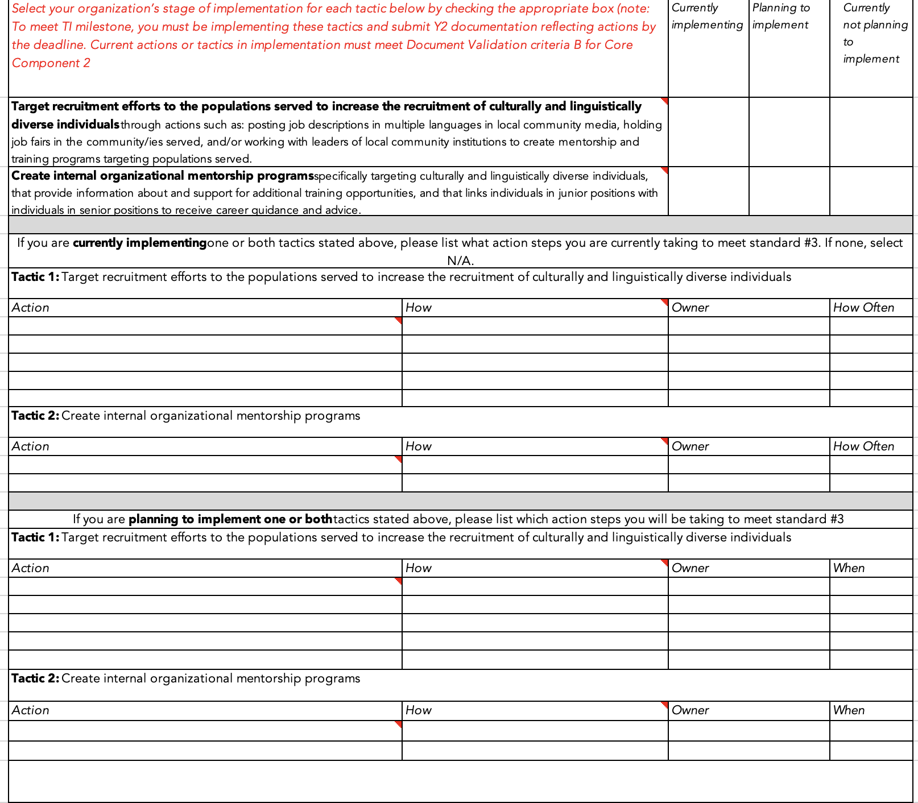

List of actions for **Tactic 1**

* + - 1. Collaborate with local schools, businesses, faith-based organizations, and other community stakeholders to expand the pool of diverse candidates for vacancies.
      2. Post job descriptions in multiple languages in local community media and hold job fairs in the communities served.
      3. Include in job postings a preference for candidates from under-represented groups, including a clear non-discrimination statement that includes race / ethnicity, ability, sexual orientation, gender identification, and gender expression.
      4. Encourage staff referrals and consider offering incentives for successful referrals.
      5. Regularly assess the organization’s hiring, retention, and promotion data and compare the demographics of this data to the service community’s demographics.

List of actions for **Tactic 2**

1. Establish volunteer, work-study, and internship programs in partnership with local health career training programs based in community colleges and universities, to create a recruitment pipeline.
2. Promote diverse staff members into positions where their cultural and linguistic capabilities can provide unique contributions to planning, policy, and decision-making processes.

**NOTE ON FILLING IN THE POLICY TEMPLATE BELOW!**

The actions you selected from the “List of actions” above, should be the same you indicate in the action plan **and** policy template. In practice, you must select action steps from a drop-down in the template OR write in the action steps if printing or implementing an action not indicated in the drop down. If helpful, you may attach the completed action plan as an appendix to your completed policy.

CLAS Standards 3 Policy example: Recruitment, Promotion, and Supporting a Diverse Governance, Leadership, and Workforce

TIN # [insert TIN]

Practice Name [insert practice name]

This policy guides [insert practice name] in achieving and maintaining a diverse governance, leadership, and workforce that reflects the cultural and linguistic needs of the clients and communities we serve. This policy is aligned with Standard 3 of the National Standards for Culturally and Linguistically Appropriate Services (CLAS) in Health and Health Care:

Recruit, promote, and support a culturally and linguistically diverse governance, leadership, and workforce that are responsive to the population in the service area.

To the end of CLAS Standard 3, [insert practice name] will:

* *Recruit and hire staff, leaders, and board members from diverse backgrounds that match our service area. (example)*
* *[Insert tactic and action(s) from table to meet standard here]*
* *[Insert tactic and action(s) from table to meet standard here]*
* *[Insert tactic and action(s) from table to meet standard here]*
* *[Insert tactic and action(s) from table to meet standard here]*

Appendix/Appendices

*[Attach completed action plan from Excel sheet by copying the complete table and pasting as an image to your completed policy]*

Resources specific to Standard 3

|  |  |  |  |
| --- | --- | --- | --- |
|  | **Resource** | **Description** | **Link** |
| **For additional reading** | **START HERE**  Reflecting and Respecting Diversity checklist | This checklist will help you assess the diversity of your team and provide you with insights into areas that may benefit from further attention or improvement. | **Included in Appendix 2: Resources for implementation** |
| Diversity in Governance and Leadership checklist | This checklist is intended to guide you in assessing diversity in your governance and leadership. It includes practices that organizations with and without a board should have in place. | **Included in Appendix 2: Resources for Implementation** |
| 6 Ways to Improve Diversity in your Hiring (article) | The article discusses strategies to improve diversity and equity in healthcare hiring practices. It emphasizes the importance of addressing implicit bias, standardizing the interview process, expanding the candidate pool, and holding organizations accountable for diversity goals. | <https://store.healthecareers.com/resources/dei/6-ways-to-improve-diversity-in-your-hiring> |
| **For a deep dive** | Diversity in Healthcare: 10 Tips for Managing a Diverse Workforce (article) | This article explains the benefits, challenges and strategies of managing diversity in healthcare, and provides an infographic to illustrate the key points and 10 tips for managing a diverse workforce | https://healthcaremba.gwu.edu/blog/diversity-in-healthcare-workforce |
| Best Board Practices Checklist: Board Self Evaluation Process | This webpage from the AHA’s Trustee Services includes a checklist of questions to help boards of hospitals or health systems evaluate their own performance and governance practices. | <https://trustees.aha.org/sites/default/files/trustees/Best_practices_self_evaluation.PDF> |
| Equity of Care: A Toolkit for Eliminating Healthcare Disparities | This toolkit for improving health equity provides information and resources in three areas:   * Collection and use of race, ethnicity and language preference (REAL) data. * Cultural competency training. * **Diversity at the leadership and governance levels.** | http://www.hpoe.org/Reports-HPOE/equity-of-care-toolkit.pdf |

Theme 1: Governance, Leadership, and Workforce

## Standard 4: Educate and train governance, leadership, and workforce in culturally and linguistically appropriate policies and practices on an ongoing basis

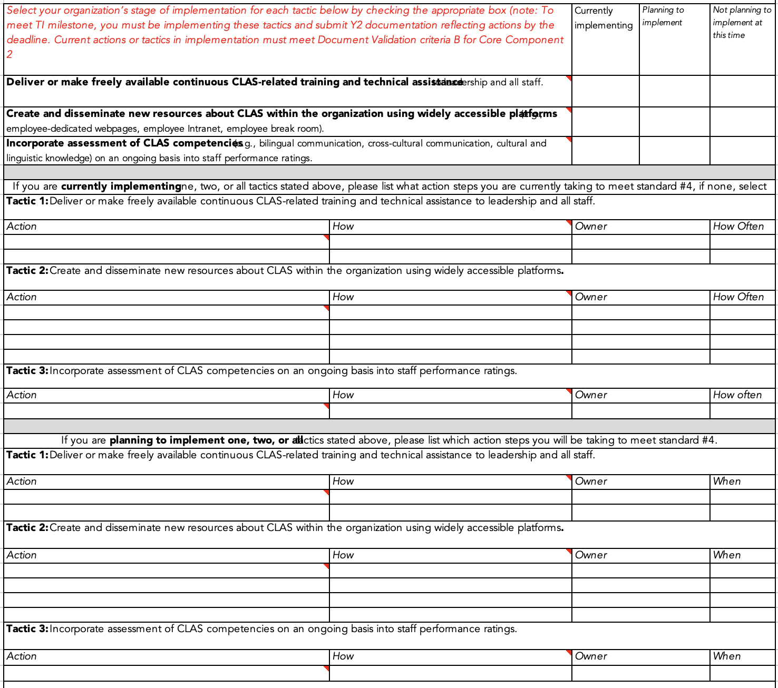

**List of actions for Tactic 1**

Establish an ongoing employee education program that at a minimum requires cultural competency training for all new staff upon hire and for existing staff on at least an annual basis.

Allocate a portion of the annual budget specifically for CLAS and cultural competency training.

List of actions for **Tactic 2**

1. Offer training in a variety of formats (live in-person, live online, self-paced, individual or group training (e.g., in-services, brown bag seminars) on a variety of topics (e.g., implicit bias, health literacy, and cross-cultural communication).
2. Evaluate education and training.
3. Encourage staff to volunteer in the community and to learn about community members and other cultures, and work with community leaders and cultural brokers to create opportunities for such interactions.
4. Take advantage of live and Web-based health disparities and cultural competency continuing education programs for clinicians and practitioners.

List of actions for **Tactic 3**

1. Incorporate assessment of cultural and linguistic competencies (e.g., bilingual and cross-cultural communication) into staff performance ratings.

**A NOTE ON FILLING IN THE POLICY TEMPLATE BELOW!**

The actions you selected from the “List of actions” above, should be the same you indicate in the action plan and policy template. In practice, you must select action steps from a drop-down in the template OR write in the action steps if printing or implementing an action not indicated in the drop down. If helpful, you may attach the completed action plan as an appendix to your completed policy.

CLAS Standard 4 Policy example: Education and Training for Governance, Leadership, and Workforce in CLAS

TIN # [*insert TIN*]

Practice Name [*insert practice name*]

The following policy is intended to guide [*insert practice* name] in adhering to Standard 4 of the Culturally and Linguistically Appropriate Services (CLAS) Standards:

Educate and train governance, leadership, and workforce in culturally and linguistically appropriate policies and practices on an ongoing basis.

Our practice is committed to building the capacity of governance, leadership, and workforce to provide high-quality, culturally and linguistically appropriate services to all clients, regardless of their race, ethnicity, language, religion, gender, sexual orientation, disability, or socioeconomic status. To achieve this goal, our practice will:

* *Conduct a regular assessment of the cultural and linguistic needs and preferences of our patient population and the community served by our practice. (example)*
* *[Insert tactic and action(s) from table to meet standard here]*
* *[Insert tactic and action(s) from table to meet standard here]*
* *[Insert tactic and action(s) from table to meet standard here]*
* *[Insert tactic and action(s) from table to meet standard here]*

Appendix/Appendices

*[Attach completed action plan from Excel sheet by copying the complete table and pasting as an image to your completed policy]*

### Resources specific to Standard 4

|  |  |  |  |
| --- | --- | --- | --- |
|  | **Resource** | **Description** | **Link** |
| **For additional reading - training resources** | CLAS Standards Training and Resources | This website from the Governor’s Interagency Council on Health Disparities (WA) offers e-learning modules and materials for in-person trainings to meet the National Standards for Culturally and Linguistically Appropriate Services in Health and Health Care (CLAS Standards).   * E-Learning Modules: Designed to provide foundational knowledge about CLAS Standards in a 30-minute, engaging format2. * In-Person Curriculum: Adaptable materials for 90-minute sessions, covering topics like governance, communication, and continuous improvement. | <https://healthequity.wa.gov/councils-work/clas-standards-training-and-resources> |
| Session 2 - Introduction to CLAS: Governance, Leadership, and Workforce | E-learning module from the website above covering the 2nd theme and related CLAS Standards. | <http://dohmedia.doh.wa.gov/cfh/clas/session2/index.html> |
| A Physician’s Guide to Culturally Competent Care | **Requires registration** Online program (9 hours total) covering key cultural and linguistic concepts in a practical and meaningful way, using case studies, pre- and post-tests, self-assessment exercises, and more.   The program is accredited for physicians, physician assistants, and nurse practitioners, providing instant online grading and up to nine CME/CEU hours at no cost | <https://www.train.org/main/course/1023488/details?activeTab=reviews> |
| **For a deeper dive** | Effective Communication For Healthcare Teams: Addressing Health Literacy, Limited English Proficiency and Cultural Differences | **Requires registration.**  This 3-module course aims to raise the quality of interactions between health care professionals and patients by providing an interactive guide to understanding health literacy, cultural competency and limited English proficiency. | <https://www.train.org/main/training_plan/3985> |
| Conversations About Culture: Video and Lesson Plan | The web page presents a module on **Cultural Humility**, emphasizing its importance for effective cross-cultural communication and collaboration. It includes a video and lesson plan aimed at students, educators, and practitioners to foster ongoing self-reflection, self-critique, and collaborative work with diverse clients. | <https://socialwork.buffalo.edu/resources/conversations-about-culture.html#collapsible_3> |
| TeamSTEPPS 3.0 (Team Strategies and Tools to Enhance Performance and Patient Safety) Program | TeamSTEPPS is an evidence-based set of teamwork tools, aimed at optimizing patient outcomes by improving communication and teamwork skills among healthcare teams, including patients and family caregivers. | <https://www.ahrq.gov/teamstepps-program/index.html> |

Glossary

* **Cross-Cultural Communication**: also known as **intercultural communication,** refers to how people from different cultural backgrounds talk to each other. It's like understanding the unique ways of speaking and interacting when folks with diverse ethnic, tribal, or geographical origins communicate. Because of these differences, there's a higher chance of misunderstandings in such situations.
* **Cultural competence**: The ability of health care providers and organizations to understand and respond effectively to the cultural and linguistic needs of patients and communities.
* **Cultural humility**: A lifelong process of self-reflection and learning that involves recognizing one's own biases and limitations and engaging with diverse cultures in a respectful and curious way.
* **Health disparities**: Differences in health outcomes and access to health care that are closely linked to social, economic, and environmental factors, such as race, ethnicity, income, education, and geography.
* **Health equity**: The state in which everyone has the opportunity to attain their full health potential, regardless of social or economic factors.
* **Health Inequality**: differences, variations, and disparities in the health achievements of individuals and groups of people.
* **Health Inequity**: difference or disparity in health outcomes that is systematic, avoidable, and unjust.
* **Health literacy**: The degree to which individuals have the capacity to obtain, process, and understand basic health information and services needed to make appropriate health decisions.
* **Language access**: The ability of individuals with limited English proficiency (LEP) or who are deaf or hard of hearing to communicate effectively with health care providers and organizations through the use of qualified interpreters, translators, and other assistive devices or technologies.
* **Linguistic competence**: The capacity of health care providers and organizations to communicate effectively and respectfully with patients and communities of diverse languages, dialects, and literacy levels.
* **Social Determinants of Health:** The complex, integrated, and overlapping social structures and economic systems that are responsible for most health inequities. These social structures and economic systems include the social environment, physical environment, health services, and structural and societal factors. Social determinants of health are shaped by the distribution of money, power, and resources throughout local communities, nations, and the world.

Appendices

## Appendix 1: Step-by-Step guide to NCLAS[1]

**Program Year 2: Laying the Foundation (4/2024 - 9/2024)**

1. Initiating Self-Assessment (Standard 2): Begin your journey by conducting a self-assessment using the CLAS Self-Assessment Tool. This will help you gauge your current capabilities in providing culturally competent services and identify areas that need enhancement.
2. Understanding Patient Diversity (Standard 3): Gather data on your patients’ race, ethnicity, language, disability status, socioeconomic status, gender, and sexual orientation. This information will help you comprehend the diverse backgrounds of your patients and tailor your services to their unique needs. Focus on building governance, leadership, and workforce that reflects the diversity of your patients through recruitment and promotion practices.
3. Cultural Sensitivity in Practice (Standard 4): Strive to understand your patients’ cultural beliefs, values, practices, and attitudes towards health and treatment. This knowledge will enable you to provide care that respects and responds to the cultural and linguistic needs of your patients. Ensure your staff is trained in culturally sensitive practices.

**Program Year 3: Building on the Foundation (10/2024 - 9/2025)**

1. Strategic Planning and Evaluation (Standard 5): Integrate cultural competence into your practice’s goals and operations. Regularly assess your cultural competence and use data for benchmarking to track your progress and make necessary adjustments.
2. Promoting Equity through Policies (Standard 6): Develop policies that foster equity in hiring, retention, and promotion practices. This should include benefits offered, non-discrimination policies, and grievance procedures.
3. Ensuring Accessibility of Services (Standard 7): Provide adaptive services and interpretation. Ensure accessibility for patients with disabilities. Address literacy needs by simplifying written materials and translating them into key languages. Foster a welcoming environment with non-discrimination notices, universal signs, and inclusive symbols. Use sensitive, gender-neutral language.
4. Tailoring Services to Patient Needs (Standard 8): Use the data and knowledge about your patients to offer services that meet their cultural, health, literacy, access, and communication needs.
5. Reflecting Community Diversity in Staff (Standard 9): Implement policies to hire, promote, and retain staff that reflect the cultural, racial, and linguistic backgrounds of your patient population.
6. Cultivating Cultural Competence through Training (Standard 10): Incorporate cultural competence training into staff meetings, employee orientation, and ongoing evaluations.
7. Engaging the Community (Standard 11): Collaborate with community members as cultural brokers. Seek joint funding opportunities and involve the community in your board.
8. Tracking Progress (Standard 12): Use the data from the assessment process to guide changes in policy and practice. Review and document changes annually and establish a system for monitoring progress.
9. Sharing Insights (Standard 13): Disseminate your learnings about cultural competence, such as data, best practices, and successes, with your staff, colleagues, and the community.

Appendix 2: Resources for implementation

### Standard 2 & 3-specific: Checklist to Facilitate the Development of Culturally and Linguistically Competent Primary Health Care Policies and Structures[2]

The goal of this checklist is to facilitate policy and procedure-making that supports culturally and linguistically competent primary health care services.

Does your program have:

A mission statement that articulates its principles, rationale and values for culturally and linguistically competent health and mental health care service delivery (if applicable)?

Policies and procedures that support a practice model which incorporates culture in the delivery of services to culturally and linguistically diverse groups?

Structures to assure the meaningful participation of consumers and communities in planning, delivery and evaluation of services?

Processes to review policy and procedures systematically to assess their relevance for the delivery of culturally competent services?

Policies and procedures for staff recruitment, hiring and retention that will achieve the goal of a diverse and culturally competent workforce?

Policies and resources to support ongoing professional development and in-service training (at all levels) for awareness, knowledge and skills in the area of cultural and linguistic competence?

Policies to ensure that new staff are provided with training, technical assistance and other supports necessary to work within culturally and linguistically diverse communities.

Position descriptions and personnel/performance measures that include skill sets related to cultural and linguistic competence?

Fiscal support and incentives for the improvement of cultural competence at the board, agency, program and staff levels?

Policies for and procedures to review periodically the current and emergent demographic trends for the geographic area it serves.

Methods to identify and acquire knowledge about health beliefs and practices of emergent or new populations in service delivery areas?

Policies and allocated resources for the provision of translation and interpretation services, and communication in alternative formats?

Policies and resources that support community outreach initiatives for those with limited English proficiency and/or populations that are not literate or have low literacy skills?

Requirements that contracting procedures and proposals and/or request for services include culturally and linguistically competent practices?

Reflecting and Respecting Diversity Checklist[3] (Standard 3)

**Step 1. Reflect Local Diversity in your workplace**

Staff diversity (race, ethnicity, gender, culture, disability status, sexual orientation) is proportional to, or reflects, the populations in the service area.

Data on staff race, ethnicity, language (REL), sex, disability status, sexual orientation is collected.

Policies and procedures promote workforce diversity.

**Step 2. Recruit a diverse workforce**

A designated staff member oversees diversity recruiting and reflects diversity needed in organization.

A percentage of the annual budget is designated to culturally competent hiring practices.

Job descriptions reflect desired linguistic, cultural competence skills and values.

Recruitment efforts include strategies to reach out to the racial and ethnic minorities in your community.

Job openings are advertised in diverse media.

Internship programs exist.

A staff referral program is in place.

The recruiting process involves diverse organizations and individuals (cultural, LGBT, disabilities, and military veterans), health fairs, etc.

**Step 3. Retain and promote diverse employees**

Retention, career development and advancement plans exist for staff from diverse racial, ethnic and cultural backgrounds, ability status, and military veterans.

Equal benefits are offered to same sex partners and a broad definition of family is adopted.

Policies about time off for holidays and religious observances consider the diversity of the workforce.

Employee certification programs encompass cultural competence.

Mandatory cultural competence training is offered.

Appendix 3: Diversity in Governance and Leadership

### Step-by-step guide to Governance and Leadership assessment

As part of assessing the diversity of your workforce, assessment of your organization’s governance and leadership is also part of CLAS Standards. However, the process for governance and leadership is a bit more involved. Here’s a step-by-step guide for conducting a board assessment with a focus on diversity and CLAS (Culturally and Linguistically Appropriate Services) Standards:

1. **Clarify the Purpose:** The purpose of the assessment should be clarified to everyone. It’s not to be judgmental or to focus only on weaknesses and negative aspects. Its purpose is to help the board and/or leadership get to the next phase of development. In the context of diversity, the purpose would be to assess how well the board and/or leadership is advancing and sustaining organizational governance and leadership that promotes CLAS and health equity.
2. **Preparation:** Define clear objectives for the assessment, ensuring they align with diversity and CLAS Standards.
3. **Designated Leadership**: Assign a specific person or committee with the responsibility of guiding the self-assessment process. This could be a Diversity and Inclusion Officer, a Governance Committee, or a similar role or group. Their tasks would include ensuring that the process is conducted fairly and objectively, and that all board members understand the purpose and process.
4. **Conducting the assessment**: Discuss the Diversity in Governance and Leadership checklist to make sure everyone on your board and/or leadership team is familiar with the contents, the assessment process, and has a chance to ask detailed questions.
5. **Confidentiality**: Expect confidentiality. Opinions and comments expressed during the process should not be attributed to individual board members but should be shared in an aggregate report following the assessment. This ensures that board members feel safe expressing their true opinions about the board’s diversity practices.
6. **Analyze responses:** Review responses to identify areas of strength and opportunities for improvement in board/leadership diversity and CLAS Standards compliance.
7. **Post-Assessment Action Plan**: After the assessment, the designated leadership should develop an action plan based on the results. This plan should outline specific steps to address areas of improvement identified in the assessment. In the context of diversity, this could include strategies to improve recruitment and support of a diverse board, or initiatives to better promote CLAS and health equity.
8. **Follow-Up and Review**: The designated leadership should also be responsible for ensuring that the action plan is implemented and periodically reviewed. This includes tracking progress against the plan, adjusting the plan as necessary, and reporting back to the board on progress.
9. **Accountability**: Demonstrate accountability as a serious organizational value. In this context, it could mean implementing measures to hold the board accountable for following through on the action plan. Such as regular progress reports, performance metrics, or even linking progress to board member evaluations.

Diversity in Governance and Leadership checklist[4] (Standard 3)

Similar to the *Respecting and Reflecting Diversity Checklist,* this checklist is intended to guide you in assessing diversity in your governance and leadership. It includes practices that organizations should have in place, and additional practices that organizations with a board of directors should have in place.

Leadership has discussed the issue of diversity of its workforce and the management team.

A policy encouraging diversity across the organization has been approved by leadership.

The policy is reflected in your mission and values statement and is visible on documents seen by your employees and the public.

Your strategic plan emphasizes the importance of diversity at all levels of your workforce.

There is a designated high-ranking member of your staff responsible for coordinating and implementing your diversity strategy.

Leadership has set goals on organizational diversity, culturally proficient care, and eliminating disparities in care to diverse groups as part of your strategic plan.

Sufficient funds have been allocated to achieve your diversity goals.

Diversity awareness and cultural proficiency training is mandatory for all senior leadership, management, and staff.

Diversity awareness is part of your management and retreat agenda.

The management team’s compensation is linked to achieving your diversity goals.

Succession/advancement plan for your management team is linked to your overall diversity goals.

**For organizations with a board of directors. In addition to the previous practices:**

The board has discussed the issue of diversity of the Board, its workforce, and the organization’s management team.

There is a board-approved policy encouraging diversity across the organization.

The policy is reflected in your mission and values statement and is visible on documents seen by your employees and the public.

The board has set goals on organizational diversity, culturally proficient care, and eliminating disparities in care to diverse groups as part of your strategic plan.

Your organization has a process in place to ensure diversity reflecting your community on your Board, subsidiary, and advisory boards.

Diversity awareness is part of your board retreat agenda.

Appendix 4: **Example** action plan

Standard 2:Advance and sustain organizational governance and leadership that promotes CLAS and health equity through policy, practices, and allocated resources.

|  |  |  |  |  |
| --- | --- | --- | --- | --- |
| *Select your organization’s stage of implementation for each tactic below by checking the appropriate box (note: if you select only “not implementing at this time”, you may not meet the TIP milestone. To meet milestone, you should at minimum, plan to implement activities described in this standard)* | | *Currently implementing* | *Planning to implement* | *Not planning to implement at this time* |
| **Identify and designate a CLAS champion or champions**, who are supported by the organization’s leadership, and whose specific responsibilities include (at a minimum) continuous learning about, promoting, and identifying and sharing educational resources about CLAS and the National CLAS Standards throughout the organization. | |  |  |  |
| **Create and implement a formal CLAS implementation plan** that is (at a minimum) endorsed and supported by the organization’s leadership, that describes how each Standard is understood, how each Standard will be implemented and assessed, and who in the organization is responsible for overseeing implementation. | |  |  |  |
|  | | | | |
| If you are **currently implementing** one or both tactics stated above, please list what action steps you are currently taking to meet standard #2, if none, select N/A. | | | | |
| **Tactic 1**: Identify and designate a CLAS champion or champions. | | | | |
| *Action* | *How* | | *Owner* | *How Often* |
| 1. N/A 2. N/A | N/A | | N/A | N/A |
| **Tactic 2**: Create and implement a formal CLAS implementation plan. | | | | |
| *Action* | *How* | | *Owner* | *How Often* |
| 1. N/A 2. N/A 3. N/A | N/A | | N/A | N/A |
|  | | | | |
| If you are **planning to implement one or both** tactics stated above, please list which tactics and action steps you will be taking to meet standard #2 | | | | |
| **Tactic 1**: Identify and designate a CLAS champion or champions. | | | | |
| *Action* | *How* | | *Owner* | *When* |
| **1:** Identify and designate an individual CLAS champion with specific responsibilities that include promoting the incorporation of the CLAS Standards. Includes individuals representing diverse communities (e.g., racial/ethnic minority, LGBTQIA+, and individuals with disabilities). **2.** N/A | * + 1. Initially, poll staff on assuming CLAS champion role. Depending on results, then assign an individual to assume responsibilities. | | *Doctor* | 1. *6/30/24* |
| **Tactic 2**: Create and implement a formal CLAS implementation plan. | | | | |
| *Action* | *How* | | *Owner* | *When* |
| **1:** Create a strategic plan that incorporates policies, procedures, staff and financial resources, and organizational systems to support CLAS efforts. **2:** Embed a commitment to culturally competent care in the vision, goals, mission, and strategic plan of the organization. **3**: Regularly review and update organizational policies and practices to reflect the CLAS Standards. | 1. During upcoming annual strategic planning process, add CLAS to the list of priorities. 2. Supplement current vision, mission, and goals statements to include commitment to culturally competent care, and in the strategic plan, detail how our organization will deliver on this commitment.  3. Embed in policies relating to CLAS Standards, stipulations on conducting annual reviews/audits and updates, if needed, of policies. | | *NP (CLAS champion) & Dr.* | 1. *7/26/24* 2. *7/26/24* 3. *7/12/24 and every year going forward.* |

Standard 4:Educate and train governance, leadership, and workforce in culturally and linguistically appropriate policies and practices on an ongoing basis.

|  |  |  |  |  |  |  |
| --- | --- | --- | --- | --- | --- | --- |
| *Select your organization’s stage of implementation for each tactic below by checking the appropriate box (note: if you select only “not implementing at this time”, you may not meet the TIP milestone. To meet milestone, you should at minimum, plan to implement activities described in this standard)* | | | *Currently implementing* | *Planning to implement* | | *Not planning to implement at this time* |
| **Deliver or make freely available continuous CLAS-related training and technical assistance** to leadership and all staff. | | |  |  | |  |
| **Create and disseminate new resources about CLAS within the organization using widely accessible platforms** (e.g., employee-dedicated webpages, employee Intranet, employee break room) | | |  |  | |  |
| **Incorporate assessment of CLAS competencies** (e.g., bilingual communication, cross-cultural communication, cultural and linguistic knowledge) on an ongoing basis into staff performance ratings. | | |  |  | |  |
| **Leave blank** | | | | | | |
| If you are **currently implementing** one, two, or all tactics stated above, please list what action steps you are currently taking to meet standard #4, if none, select N/A | | | | | | |
| **Tactic 1:** Target recruitment efforts to the population served to increase the recruitment of culturally and linguistically diverse individuals. | | | | | | |
| *Action* | *How* | *Owner* | | | *How Often* | |
| **1.** N/A **2.** N/A | N/A |  | | |  | |
| **Tactic 2:** Create and disseminate new resources about CLAS within the organization using widely accessible platforms (e.g., employee-dedicated webpages, employee Intranet, employee break room). | | | | | | |
| *Action* | *How* | *Owner* | | | *How Often* | |
| 1. N/A 2. N/A 3. N/A 4. N/A | N/A |  | | |  | |
| **Tactic 3**: Incorporate assessment of CLAS competencies on an ongoing basis into staff performance ratings. | | | | | | |
| *Action* |  | *Owner* | | | *How Often* | |
| 1. N/A |  |  | | |  | |
|  | | | | | | |
| If you are **planning to implement one, two, or all** tactics stated above, please list which tactics and action steps you will be taking to meet standard #3 | | | | | | |
| **Tactic 1**: Target recruitment efforts to the population served to increase the recruitment of culturally and linguistically diverse individuals. | | | | | | |
| *Action* | *How* | *Owner* | | | *When* | |
| **1**: Establish an ongoing employee education program that at a minimum requires cultural competency training for all new staff upon hire and for existing staff on at least an annual basis.  2: Allocate a portion of the annual budget specifically for CLAS and cultural competency training. | * + 1. Leverage Equality Health training offerings to meet requirement.     2. During annual strategic planning process, add to line item for training and development a component specific to CLAS and cultural competency training. | *NP (CLAS champion) & Director of Finance* | | | *1. 7/31/2024* *2. 12/13/2024* | |
| **Tactic 2:** Create and disseminate new resources about CLAS within the organization using widely accessible platforms (e.g., employee-dedicated webpages, employee Intranet, employee break room). | | | | | | |
| *Action* | *How* | *Owner* | | | *When* | |
| **1:**Offer training in a variety of formats (live in-person, live online, self-paced, individual or group training (e.g., in-services, brown bag seminars) on a variety of topics (e.g., implicit bias, health literacy, and cross-cultural communication).  2: Evaluate education and training.  **3:** Encourage staff to volunteer in the community and to learn about community members and other cultures, and work with community leaders and cultural brokers to create opportunities for such interactions.  **4:** Take advantage of live and Web-based health disparities and cultural competency continuing education programs for clinicians and practitioners. | 1. Coordinate with Equality Health to offer training and suggest additional training resources. 2. Develop evaluation survey and collect following the completion of training (post-survey). 3. Leverage CBO connections to share community events and distribute to staff. 4. Same as number 1. | *NP, PM, and Dr. Klein* | | | 1. *7/10/24* 2. *12/6/2024 (start date, then annually)*  3-4. *7/26/24* | |
| **Tactic 3**: Incorporate assessment of CLAS competencies on an ongoing basis into staff performance ratings. | | | | | | |
| *Action* | *How* | *Owner* | | | *When* | |
| *[write-in example]* 1. *Define competencies*  2. *Develop assessment criteria*  3. *Integrate into performance ratings*  4. *Communicate.* | 1. Conduct a job analysis to identify essential CLAS-related tasks and responsibilities. Engage with diverse stakeholders for a well-rounded perspective.  2. Establish SMART objectives for each competency. Use rubrics to standardize evaluation.  3. Update the **performance management system** to include CLAS competencies. Ensure alignment with overall **organizational goals**.  4. Launch an **internal campaign** to raise awareness. Provide **training workshops** and **feedback mechanisms** to support staff adaptation. | *Practice Manager* | | | 1*. 8/2/24*  2*. 8/9/24*  3*. 8/16/24*  4*. 8/23/24* | |

1. Adapted from Massachusetts Department of Public Health. Making CLAS Happen: Six Areas for Action. Tool 1.1: Getting started with CLAS. Published 2013. Accessed Feb 7, 2024. https://www.mass.gov/doc/chapter-1-foster-cultural-competence/download
2. Adapted from: National Center for Cultural Competence. Policy Brief 1- Rationale for Cultural Competence in Primary Health Care. https://gucchd.georgetown.edu/nccc/policy_brief_1.html. Accessed December 11, 2023.
3. Adapted from Making CLAS Happen (2013) | Chapter 5: Reflect and Respect Diversity. Massachusetts Department of Public Health. 2013. <https://www.mass.gov/doc/chapter-5-reflect-and-respect-diversity/download>. Accessed February 1, 2024.
4. Adapted from Does Your Hospital Reflect the Community It Serves? A Diversity and Cultural Proficiency Assessment Tool for Leaders. American Hospital Association, National Center for Healthcare Leadership, et al. 2004. <https://www.aha.org/system/files/2018-02/DiversityTool.pdf>. Accessed February 20, 2024.